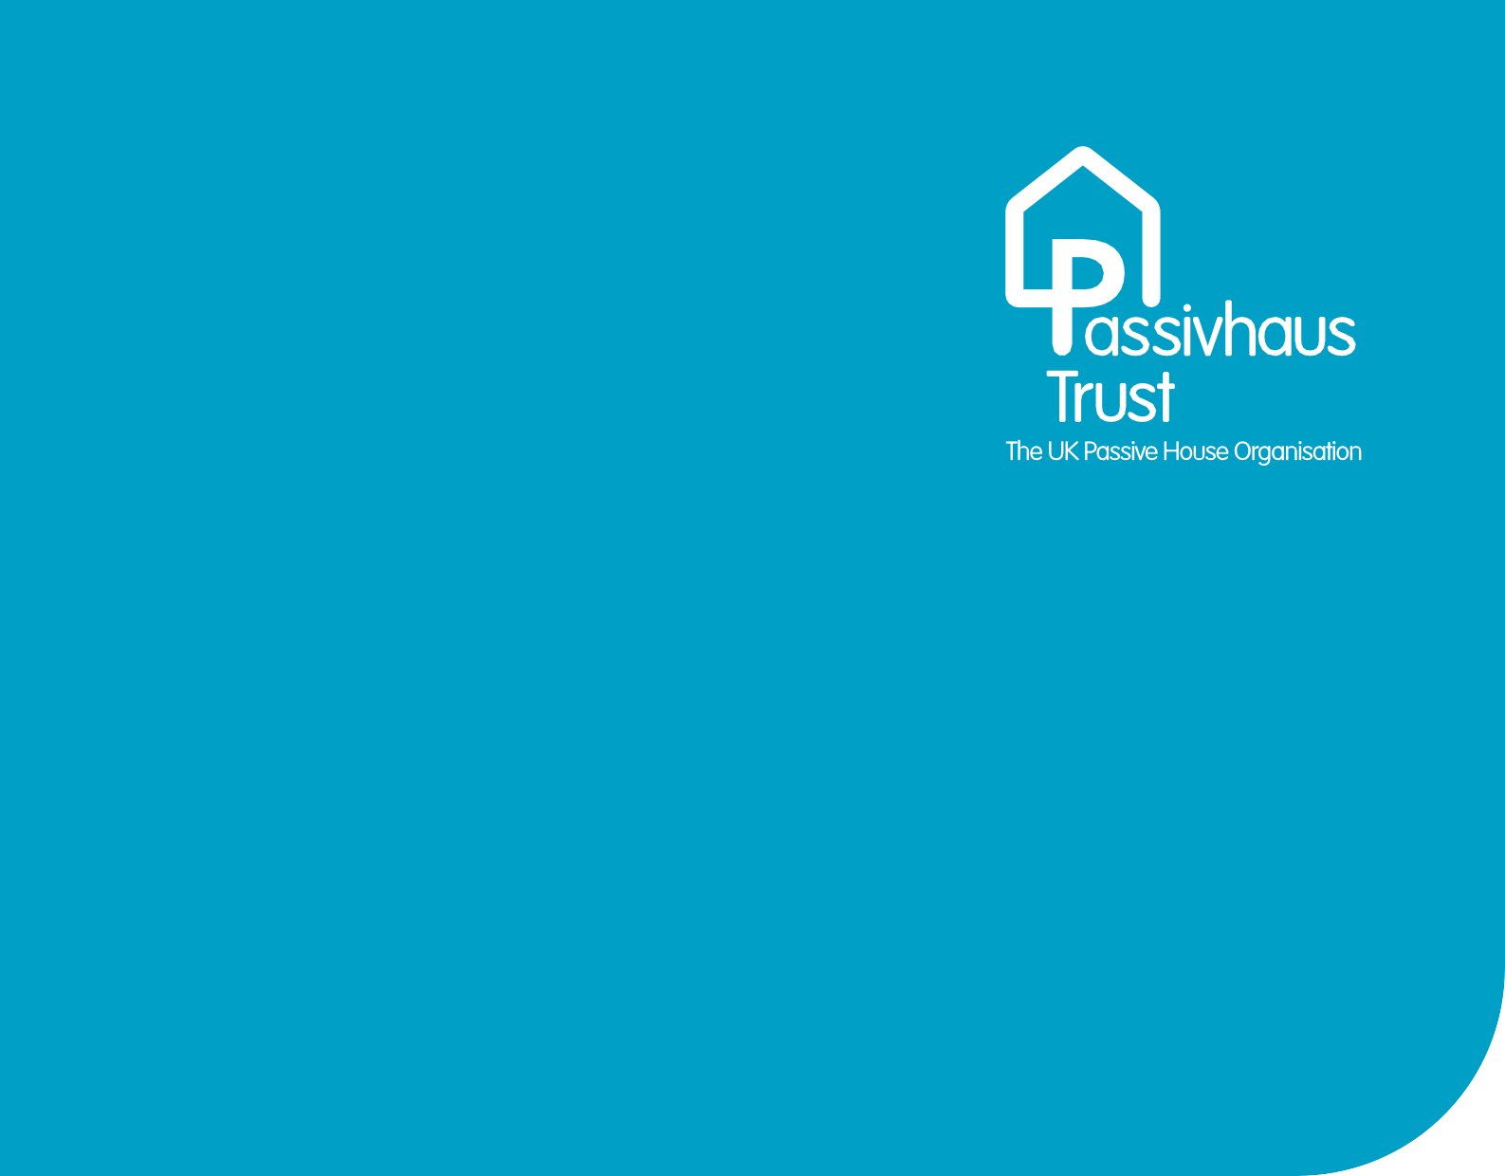

Passivhaus Certifier
Scope of Services
Editable Template

September 2023

Version 1.1

Passivhaus Certifier scope of services
This document is provided in an editable form to accompany the guidance paper developed by the UK Certifier’s Circle and published by the Passivhaus Trust.
This template scope of services is designed to be adaptable and applicable to various project types and scales. Specific project requirements and contractual agreements may require adjustments and additions to this generic scope of services. It is crucial to consult with a certified Passivhaus Designer/Consultant and/or Passivhaus Certifier to tailor the scope to the specific needs and requirements of each project. Their expertise will help navigate the intricacies of the certification process and ensure successful delivery of a Passivhaus project.
Collaboration and communication among all project stakeholders are vital for the effective delivery of a Passivhaus project and the successful achievement of Passivhaus certification.
Download the full accompanying guidance at https://pht.guide/CertifierScopeofServices.

TABLE 1 Core scope of services

Project Stage | Item | Activity | Notes
1  INITIAL REVIEW | 1.1  Certification  process | 1.1.1 Confirm certification approach with consultant and Passive House Institute (PHI) if required, including verifying climate data set, number of PHPPs and general boundary conditions | Once the assessment against the Passivhaus criteria has been  undertaken, further iterations are  not included
1  INITIAL REVIEW | 1.1  Certification  process | 1.1.2 Issue initial list of evidence required for  Passivhaus certification
1  INITIAL REVIEW | 1.1  Certification  process | 1.1.3 Issue file structure for collating design and  construction evidence
1  INITIAL REVIEW | 1.1  Certification  process | 1.1.4 Set up project on PHI portal  (https://certification.passivehouse.com/) or alternative methods to store information and ensure the team are clear on how to use it
1  INITIAL REVIEW | 1.2  Initial Review | 1.2.1 Review early-stage design information, and PHPP, DesignPH and supporting calculations to verify against Passivhaus certification criteria
1  INITIAL REVIEW | 1.2  Initial Review | 1.2.2 Review assumptions made in the absence of design evidence
1  INITIAL REVIEW | 1.3  Feedback | Feedback with initial technical findings including:  - Feedback on the likelihood of certification  - Feedback problems within the early-stage design  information and calculations  - Feedback risk areas within the early-stage design  information and calculations  - Initial Review confidence letter or summary for  client - upon request
continues over...

2  DESIGN  REVIEW | 2.1  Design Review | 2.1.1 Compliance review of pre-construction information* with the Passivhaus criteria | Once the assessment against the Passivhaus criteria has been  undertaken, further iterations are  not included. The assessment will commence when most of the evidence is provided. We recommend completing this stage prior to starting work on site.  * Thermal bridge calculations are produced by the designer (not the Certifier). Assessment of thermal bridge calculations used in the PHPP is at an additional cost <INSERT FEE> per calculation or <INSERT No.> within the ‘Additional Consultancy’ fee.
2  DESIGN  REVIEW | 2.1  Design Review | 2.1.2 Review the energy balance calculation in PHPP
2  DESIGN  REVIEW | 2.1  Design Review | 2.1.3 Review of dynamic modelling for summer comfort for projects where this modelling is required by Building Standards https://pht.guide/DynamicThermalModelling
2  DESIGN  REVIEW | 2.2  Feedback | Feedback with detailed technical findings including:  - Feedback on the likelihood of certification  - Outstanding information  - Assumptions  - Risk to certification  - Design Review confidence letter - upon request
2  DESIGN  REVIEW | 2.3  Construction evidence | 2.3.1 Provide project-specific construction evidence  register
3  CONSTRUCTION  REVIEW | 3.1  Feedback | 3.1.1 Provide feedback, verbal or written, including highlighting key risks to obtaining certification, in response to requests from design/site team | It is the responsibility of the design/ site team to request feedback. The Certifier is not responsible for contacting the team on a regular basis to make checks and ask for information.
4  AS-BUILT ASSESSMENT | 4.1  Quality assurance | 4.1.1 Review certification evidence provided by Passivhaus Designer/Consultant
4  AS-BUILT ASSESSMENT | 4.1  Quality assurance | 4.1.2 Provide feedback, highlighting any outstanding obstacles to obtaining certification
4  AS-BUILT ASSESSMENT | 4.2  Complete PHPP  verification | - Review final PHPP. Passivhaus designers should provide a final PHPP to the Passivhaus Certifier, updated to reflect construction information:  - final airtightness test result  - ventilation commissioning  - space heating  - domestic hot water system commissioning  - changes during construction
5  CERTIFICATION | 5.1 Completion & processing | 5.1.1 Passivhaus certifiable projects: Liaise with PHI to obtain certificate-ID
5  CERTIFICATION | 5.1 Completion & processing | 5.1.2 PHI Low Energy Building standard projects:  In some instances the project may not be certifiable to the intended Passivhaus standard but may still meet the PHI Low Energy Building standard. The Passivhaus Certifier to confirm with the client if they  wish to proceed with the certification to this alternative standard. Liaise with PHI to obtain certificate-ID
5  CERTIFICATION | 5.1 Completion & processing | 5.1.3 Non-certifiable projects:  In some instances the project may not be certifiable to any of the Passivhaus standards. In this case the client will be informed, and no further action will be taken by the Certifier.
5  CERTIFICATION | 5.2  Certification  documents | 5.2.1 Passivhaus plaque - includes XXXX plaque -  "Certified Passivhaus"
5  CERTIFICATION | 5.2  Certification  documents | 5.2.2 Passivhaus certificate and documentation

TABLE 2 Optional additional scope of services
Additional services can be provided by Certifiers – see table below.

Project Stage | Item | Activity | Notes
Additional consultancy time will be spilt over all project stages | 6  Additional services | Additional technical support is project specific and can  include:  - Support on general process  - Support / guidance to design team  - Support design / construction workshops  - Verify design / specification changes  - Collation of information
 | 7  Site visits | - Site inspection visits, timing to be agreed with site team. Limited to <INSERT No.> visits. | Passivhaus quality control is managed by the Contractor & Passivhaus Designer/Consultant (not the Certifier). Site visits are not required for certification, but strongly recommended for projects of more than 10 homes or for non-residential buildings over 500 m².
 | 8  Thermal bridge calculation review | - QA review of 2D thermal bridges
 | 8  Thermal bridge calculation review | 8.2 QA review of 3D thermal bridges
 | 9  Dynamic hygrothermal moisture calculation review | 9.1 Review
 | 10  Air pressure test | 10.1 Carry out air pressure test | This is usually carried out by a third party. Passivhaus Certifiers should only complete this for exceptional cases (e.g. building is in the middle of nowhere)
 | 11  User guidance | 11.1 Support in preparing User Guidance documentation

The Passivhaus Trust is an independent, non-profit organisation that provides leadership in the UK for the adoption of the Passivhaus standard and methodology.
Passivhaus is the leading international low energy design standard, backed with over 30 years of building performance evidence. It is a tried & tested solution that enables a meaningful transition to net-zero now. Over 65,000 buildings have been certified to this standard worldwide. The Trust promotes Passivhaus as a robust way of providing high standards of occupant comfort and health AND slashing energy use and carbon emissions from buildings in the UK.
Please find us on Twitter, Linkedin, Instagram, & Facebook @PassivhausTrust. Keep up to date with all things Passivhaus by joining our mailing list.
www.passivhaustrust.org.uk






